AI-Powered Parent-Teacher Communication & Performance Tracker

Abstract

This project introduces an AI-powered communication and performance monitoring system designed to enhance the interaction between teachers and parents, while also providing students with personalized academic insights. The core objective of this system is to bridge the communication gap between educators and guardians, especially in tracking and responding to students’ academic progress and attendance. The system architecture is divided into two distinct portals: one dedicated to staff (teachers) and the other for students, each offering unique features tailored to their roles.

The staff portal is equipped with features for managing academic data, including subject creation, student registration, marks entry, and attendance tracking. Teachers can efficiently maintain academic records and update them as necessary. A key highlight of this system is the integration of a Random Forest Classifier, a robust machine learning algorithm, which is trained using historical academic and attendance data to predict and flag students at risk due to poor performance or irregular attendance. Upon identification of such students, the system automatically generates and sends notification emails to their respective parents. These emails inform guardians about their child’s academic issues, encouraging timely intervention and support. This automation eliminates the manual overhead traditionally required to monitor each student and contact parents individually, thus saving time and increasing efficiency.

The student portal, on the other hand, is developed with features that empower students to take responsibility for their academic journey. Through this portal, students can view their attendance records, check subject-wise performance, and monitor academic trends over time using a dynamic and user-friendly dashboard. Additionally, an AI-based chatbot is incorporated to assist students in resolving academic queries. This chatbot uses natural language processing to understand and respond to common questions related to subjects, assignments, and exam preparation, thereby enhancing the learning experience and making academic support available 24/7.

To achieve seamless integration and a smooth user experience, this system is built using a combination of modern web technologies. The Flask framework is used to train the machine learning model and convert it into a RESTful API that can be consumed by other components. Node.js handles the backend logic, database operations, and API integration, serving as the backbone of the application's server-side functionality. The React.js library is employed on the frontend to build responsive, component-based user interfaces that adapt to different user roles (teacher or student) and provide real-time updates.

This full-stack AI-driven solution offers several advantages. It enhances transparency between schools and parents, improves student accountability, reduces the administrative burden on teachers, and provides timely alerts to prevent long-term academic issues. It also serves as a scalable and modular system that can be extended to include additional features, such as SMS notifications, multilingual support, and integration with existing school ERP systems.

In conclusion, the AI-Powered Parent-Teacher Communication & Performance Tracker is a smart educational tool that leverages artificial intelligence to improve academic outcomes and strengthen the support system surrounding every student. By integrating advanced analytics and automation into everyday educational processes, this project sets a foundation for smarter, data-informed educational management.

Table of Contents
- Introduction
- Objectives
- Literature Review
- System Architecture
- Technologies Used
- Modules Description
- Machine Learning Model
- API Integration
- Results and Screenshots
- Conclusion
- Future Enhancements
- References

- Introduction

Effective communication between parents and teachers is a critical component in ensuring a student's academic success and overall development. However, in many educational institutions, there exists a persistent gap in communication that often leads to delayed recognition of a student’s declining academic performance or irregular attendance. This delay can result in missed opportunities for timely intervention, ultimately affecting the student's learning outcomes and personal growth.
In today's digital era, where data-driven solutions are transforming industries, educational systems can benefit significantly from technological advancements. Our project, titled "AI-Powered Parent-Teacher Communication & Performance Tracker," addresses this communication gap by leveraging Artificial Intelligence to monitor student performance in real-time and provide instant alerts to parents when potential issues are detected.
The primary focus of this system is to ensure early detection of academic problems by continuously analyzing key metrics such as marks and attendance. Using a machine learning algorithm—specifically the Random Forest Classifier—the system evaluates student data to identify those at risk due to poor performance or low attendance. Once identified, the system automatically sends email notifications to the respective parents, thus enabling them to take proactive steps in collaboration with educators to support their child's learning journey.
The system is designed to be accessible via two separate portals: one for staff (teachers) and one for students. The staff portal allows teachers to manage subjects, student information, marks, and attendance. It also connects to the AI model to trigger alerts when needed. The student portal, on the other hand, provides students with a personalized dashboard to track their performance and attendance. It also includes an AI-powered chatbot that can answer academic-related questions and guide students in their studies.
This approach not only enhances transparency between parents and teachers but also encourages students to be more accountable and aware of their academic status. Moreover, by integrating advanced technologies such as Flask for machine learning, Node.js for backend services, and React.js for a dynamic and responsive frontend, the system is built as a full-stack solution suitable for modern educational environments.
In essence, this project reimagines how educational institutions can use artificial intelligence to create a more connected and responsive support system for students. By promoting real-time monitoring, instant communication, and data-driven decision-making, the project offers a sustainable and scalable model that can be adopted in schools, colleges, and other academic settings.

- Objectives

The primary objective of this project is to develop a smart, AI-integrated communication system that bridges the gap between teachers, parents, and students. With the rise of digital tools and artificial intelligence, educational institutions now have the opportunity to provide more timely, transparent, and personalized support to students. The specific objectives of this project are as follows:
2.1 To Develop a Dual-Portal System for Staff and Students
A key goal of this project is to build two distinct web-based portals—one for staff (teachers) and another for students—tailored to the unique needs of each user group. The staff portal will include functionalities such as subject management, student record management, marks entry, and attendance tracking. Meanwhile, the student portal will serve as a personalized dashboard where learners can access their academic data, view attendance records, and interact with a virtual assistant. This separation of roles ensures clarity, ease of use, and efficient data access for each user.
2.2 To Use AI (Random Forest Classifier) for Performance Prediction
This project leverages machine learning to bring intelligence to student performance tracking. Specifically, a Random Forest Classifier model is trained using historical academic and attendance data to predict which students are likely to underperform or show declining academic trends. The goal is to move beyond reactive reporting and provide proactive insights, enabling early intervention before the issues escalate.
2.3 To Send Automated Emails to Parents When Students Underperform
In traditional academic environments, notifying parents of a student's poor performance is often delayed due to manual processes and administrative bottlenecks. This project automates that workflow. When the AI model flags a student for poor performance or low attendance, an email is immediately triggered and sent to the student’s parent or guardian. These notifications contain key information about the student’s academic standing and encourage parents to engage in timely support and communication with educators.
2.4 To Offer an AI Chatbot to Assist Students with Academic Queries
To enhance student engagement and provide 24/7 academic support, an AI-powered chatbot is integrated into the student portal. This chatbot is designed to answer frequently asked questions related to subjects, assignments, exam preparation, and general academic advice. The goal is to reduce student dependence on teacher availability and foster independent learning through instant, AI-driven assistance.
2.5 To Track Attendance and Monitor Student Performance Effectively
The system includes robust tools for recording, visualizing, and analyzing attendance and performance metrics. Staff members can input and update attendance regularly, while students can view their attendance statistics on their dashboards. Combined with performance data, these records help both teachers and parents monitor academic engagement and discipline. The integration of analytics and dashboards ensures that data is easy to interpret, actionable, and continuously updated.

- Literature Review

In recent years, the integration of digital technologies into education has led to the development of various Student Information Systems (SIS) aimed at improving data management, academic monitoring, and overall institutional efficiency. These systems typically provide functionalities such as attendance tracking, marks entry, and student record maintenance. However, a critical limitation of many of these systems is the lack of proactive communication tools that involve parents in real time, especially when students are struggling academically.
Several studies highlight the importance of parental involvement in a student’s academic success. According to research conducted by the National Education Association (NEA), students whose parents actively engage with their academic progress tend to perform better in school and exhibit improved behavioral outcomes. However, in traditional school settings, parent-teacher interactions are often limited to periodic meetings, which may not reflect the student's ongoing performance or challenges.
Moreover, most existing educational management systems are reactive in nature—they provide access to past data rather than predicting future academic outcomes. This creates a delay in identifying struggling students and implementing corrective actions. In contrast, modern technologies like Machine Learning (ML) offer opportunities to create predictive models that can analyze historical data and flag students who may need additional attention.
Recent literature on AI in education shows that integrating intelligent systems can greatly enhance the responsiveness of academic support frameworks. For instance, the use of classification algorithms such as Decision Trees, Naïve Bayes, and Random Forests has proven effective in student performance prediction. Among these, the Random Forest Classifier stands out for its high accuracy and robustness in handling diverse educational datasets.
Another emerging trend is the use of AI-powered chatbots to assist students outside classroom hours. These bots can respond to academic questions, guide students through subject-related issues, and offer personalized learning resources. While such bots have gained popularity in e-learning platforms, their use in school-level academic systems remains relatively underexplored.
Furthermore, communication automation—especially through email and SMS alerts—has shown to enhance parental involvement. Studies show that personalized messages sent to parents regarding their child’s progress or absenteeism lead to improved attendance rates and better performance in exams. Tools like automated email dispatchers reduce the burden on staff while maintaining consistent communication with stakeholders.
In light of these findings, this project builds upon existing technologies and research by combining machine learning-based performance prediction, real-time alert systems, and AI chatbots into a unified educational platform. By addressing the gaps in proactive communication and parental engagement, the system contributes to both academic research and practical implementation of AI in education.

5. Technologies Used
The system is developed using a combination of modern web technologies, programming frameworks, machine learning libraries, and database systems. These tools are chosen to ensure modularity, scalability, and efficient performance across all functional layers of the application. The following table summarizes the core technologies:
Component | Technology
Frontend | React.js
Backend API | Node.js (Express)
AI Model | Python (Flask + Scikit-learn)
Database | MySQL
Email Service | Nodemailer / SMTP
AI Chatbot | Python (Rule-based or GPT API)

5.1 Frontend – React.js
The frontend of the application is built using React.js, a highly popular JavaScript library developed by Facebook. React allows the development of efficient, dynamic, and responsive single-page applications (SPAs) through a component-based architecture.
Key Features:
- Component Reusability: Modular components such as forms, tables, and dashboards are reused across the staff and student portals.
- State Management: React's useState and Context API (or Redux, if needed) help manage and share data between components efficiently.
- Dynamic Rendering: Performance and attendance data are dynamically rendered as visual charts and tables.
- Responsive Design: React works seamlessly with CSS frameworks like Tailwind CSS or Bootstrap to ensure mobile-friendly layouts.
In this project, React is used to render:
- The Staff Dashboard (subject management, student list, attendance and marks entry forms).
- The Student Dashboard (performance visualization, attendance overview).
- The AI Chatbot Interface for academic support.

5.2 Backend API – Node.js with Express
The backend is implemented using Node.js, a server-side JavaScript runtime, and the Express.js framework, which simplifies REST API development. Node.js is known for its event-driven, non-blocking architecture, making it ideal for scalable web applications.
Key Functionalities Handled in Backend:
- User Authentication: Login and role-based access control for staff and students.
- CRUD Operations: Handling subject creation, student registration, marks and attendance input.
- API Communication: Receiving student data, calling the AI model via Flask, and sending predictions back to the frontend.
- Email Triggering: Upon receiving a low-performance flag from the AI, the backend triggers the email service.
Advantages:
- Lightweight and fast execution.
- Easy integration with other APIs (e.g., AI model, chatbot).
- Scalable for deployment across multiple user roles.

5.3 AI Model – Python (Flask + Scikit-learn)
To enable intelligent predictions, a Random Forest Classifier is trained using Python and the Scikit-learn library. This supervised learning model identifies students who are likely to underperform based on their marks and attendance patterns.
Steps Followed:
- Data Collection: Student academic and attendance data is collected from the database.
- Preprocessing: Data cleaning, encoding, normalization, and feature engineering are applied.
- Model Training: A Random Forest Classifier is trained on labeled data to predict student risk level.
- Model Deployment: Using Flask, the trained model is hosted as a RESTful API that accepts student data in JSON format and returns predictions.
Why Flask?
- Lightweight microframework ideal for model hosting.
- Easy to integrate with Node.js via HTTP requests.
- Supports rapid deployment and scaling with services like Docker or Heroku.

5.4 Database – MySQL
The project uses MySQL, a robust and widely-used open-source relational database management system (RDBMS), to store and manage structured academic data. MySQL ensures data consistency, integrity, and supports complex querying and reporting.
Database Design Includes:
- Users Table: Stores staff and student login credentials with roles.
- Subjects Table: Manages subjects assigned to different staff members.
- Students Table: Contains student personal and academic information.
- Marks Table: Records student marks for various subjects and tests.
- Attendance Table: Tracks daily or period-wise attendance.
- Alerts Log Table: Stores history of AI predictions and email notifications sent to parents.
Key Advantages of MySQL:
- Reliable ACID-compliant transactions.
- Structured query capabilities for advanced analytics.
- Seamless integration with Node.js using packages like mysql2 or sequelize.
MySQL serves as the backbone of data storage, providing structured datasets to both the AI model and frontend for real-time decision-making and visualization.

5.5 Email Service – Nodemailer with SMTP
An essential feature of the system is automated email alerts to parents when students are detected to be underperforming. This is implemented using Nodemailer, a Node.js module that simplifies sending emails via SMTP.
How It Works:
- The AI model sends a low-performance flag for a student.
- The backend API uses Nodemailer to prepare an email with the student's details.
- An SMTP server (e.g., Gmail, Outlook, or custom domain) is used to securely send the email.
- Email delivery is logged in the database for auditing purposes.
Email Content Includes:
- Student name and class
- Subject-wise performance or attendance report
- Suggestions for parental action
- Contact information for the staff or school
This module ensures instant and consistent communication with parents, encouraging real-time collaboration.

5.6 AI Chatbot – Python (Rule-Based or GPT API)
The student portal integrates an AI chatbot to support learners with academic-related queries, such as syllabus-related doubts, exam schedules, or subject explanations.
Two chatbot options are supported:
- Rule-Based Chatbot: Developed in Python using conditional logic for FAQs. Useful for fixed, predictable queries.
- GPT-API Integration (Optional): For advanced deployments, the chatbot can connect to a GPT-based language model (e.g., OpenAI API) for natural and context-aware responses.
Features of the Chatbot:
- Real-time Q&A interaction via chat interface.
- Capable of retrieving subject content, important dates, and reminders.
- Can escalate to human staff if the question is out of scope.
Benefits:
- 24/7 academic support for students.
- Reduces workload on teachers for repetitive queries.
- Boosts student engagement through conversational learning.

6. Modules Description
The system is divided into two primary modules: the Staff Portal and the Student Portal. Each module is designed with features tailored to its users’ specific roles and responsibilities. Together, they form a cohesive ecosystem for managing academic data, tracking student performance, and facilitating AI-powered communication between stakeholders.

A. Staff Portal
The Staff Portal serves as the control panel for teachers and academic coordinators. It allows faculty members to manage subject data, student profiles, academic records, and leverage AI functionalities for early intervention.
1. Add Subjects
Teachers can create and manage subjects assigned to their classes. This feature includes:
- Defining subject names and codes.
- Assigning subjects to specific classes or grades.
- Linking subjects to the respective teachers for easy filtering and future data entry.
This module ensures that all academic activities are mapped to the correct subject structure.
2. Add Students
Teachers or admins can register new students into the system. During registration:
- Student information such as name, ID, class, and guardian email is entered.
- Each student is mapped to a class and academic year.
- Profiles are stored in the database and become accessible across other modules (e.g., marks, attendance, alerts).
This module ensures centralized student information management for smooth academic operations.
3. Add Marks & Attendance
This is a key operational feature of the staff portal:
- Teachers can enter marks for tests, assignments, or exams.
- Attendance can be updated daily, weekly, or monthly.
- The system automatically stores and calculates summaries (e.g., average marks, total attendance days).
- Data is also used as input for AI performance analysis.
Built-in validation checks prevent data duplication and ensure accurate reporting.
4. AI Notification System
One of the system's unique features is its AI-powered student alert system:
- Once new marks or attendance data is entered, the backend triggers a call to the Flask-based Random Forest API.
- The model analyzes the student’s performance using current and past data.
- If the predicted outcome indicates low academic performance or poor attendance, an automated email alert is sent to the parent.
- These alerts contain performance summaries and recommended action.
This feature promotes early intervention, reducing the likelihood of long-term academic decline.

B. Student Portal
The Student Portal is designed to promote self-awareness and academic ownership among students. It provides personalized access to performance data and AI-driven support tools.
1. View Attendance
Students can monitor their attendance statistics in real-time:
- Monthly breakdowns showing presence, absences, and late entries.
- Attendance percentage and compliance status.
- Visual representations (charts, bars) of attendance trends over time.
This module helps students recognize attendance patterns and motivates them to improve consistency.
2. Performance Monitor
This dashboard allows students to track their academic progress:
- Subject-wise marks are displayed in tables and graphs.
- Trends over different tests or semesters are visualized to show improvement or decline.
- Feedback from the AI model (e.g., risk level: safe, warning, critical) is shown along with suggestions for improvement.
Students gain actionable insights into their strengths and areas needing attention.
3. AI Chatbot
To support independent learning, an AI-powered chatbot is integrated into the student interface:
- Students can type in academic queries such as “Explain Newton’s third law” or “When is the next exam?”
- The chatbot replies instantly using either rule-based logic or connects to a GPT-based API for intelligent natural language responses.
- The chatbot supports content retrieval, reminders, and interactive Q&A.

7. Machine Learning Model
7.1 Algorithm Used: Random Forest Classifier
The core of the intelligent performance monitoring system is built upon a Random Forest Classifier, a robust, ensemble-based machine learning algorithm known for its accuracy and reliability in classification tasks. The algorithm is chosen for its ability to handle both numerical and categorical data, resist overfitting, and perform well even with complex datasets.

7.2 Purpose
The primary objective of integrating this machine learning model is to automatically classify students as either "Normal" or "At Risk" based on their academic performance and attendance data. By leveraging historical student data, the model is trained to detect patterns associated with poor performance or irregular attendance, which are strong indicators of potential academic failure or disengagement.

7.3 Features Used for Prediction
The model takes several input features into account to make accurate predictions. These features are derived from the student academic records:
- Total Marks: The aggregate score of all subjects combined.
- Subject-wise Marks: Individual marks from different subjects provide insights into subject-level weaknesses.
- Attendance Percentage: Calculated as the number of days present divided by total working days. A lower attendance percentage often correlates with poor academic performance.
These features are normalized and fed into the Random Forest algorithm during the training phase.

7.4 Labels (Target Output)
The target variable used for training and predictions is a binary classification label:
- 0 – Normal: The student is performing within acceptable academic and attendance thresholds.
- 1 – At Risk: The student has either low marks, poor attendance, or both, and may require intervention.
The thresholds for classification can be adjusted during training based on institutional policy (e.g., below 40% in marks or less than 75% attendance).

7.5 Workflow
The end-to-end implementation of the machine learning model follows the workflow described below:
1. Data Preparation
Historical student data is collected, cleaned, and formatted. The dataset includes labeled entries that indicate whether each student was previously at risk or not, based on academic history.
2. Model Training
The Random Forest Classifier is trained using the labeled dataset. It builds multiple decision trees using bootstrapped samples and combines them to improve prediction accuracy. The trained model is evaluated using accuracy, precision, recall, and F1 score metrics.
3. Model Saving and Deployment
After achieving satisfactory performance, the trained model is serialized using Python’s joblib or pickle module and saved locally. It is then deployed using Flask, a lightweight Python web framework. The Flask app hosts the model and exposes an API endpoint /predict.
4. API Integration
The Flask API accepts POST requests with student data in JSON format. Upon receiving data, the model returns the classification result (0 or 1) along with a confidence score. This API is called by the Node.js backend whenever new academic data is entered.
5. Email Triggering
If the returned label is 1 (At Risk), the backend triggers the Nodemailer module to send an automated email to the parent or guardian. The email includes the student’s performance summary and suggestions for improvement, ensuring timely parental intervention.

7.6 Advantages of Using Random Forest
- High Accuracy: Combines the predictions of multiple decision trees to reduce variance.
- Handles Missing/Noisy Data: Performs well even with partial or messy inputs.
- Feature Importance: Provides insight into which features most influence predictions.
- Scalability: Easily expandable to handle more data as the institution grows.

8. API Integration
To ensure a seamless flow of data between the machine learning model, the backend, and the frontend interfaces, the system implements RESTful APIs. These APIs enable different components—such as the AI model hosted in Flask and the core application logic built with Node.js—to interact efficiently in a modular and scalable manner.

8.1 Flask API Endpoints
The machine learning model is deployed as a web service using Flask, a lightweight Python framework ideal for building microservices. Flask serves the trained Random Forest model and exposes endpoints that allow other parts of the system to access its prediction functionality.
/predict Endpoint
- Method: POST
- Input: JSON object containing student data, including:
  - Total marks
  - Subject-wise marks
  - Attendance percentage
- Processing: The endpoint loads the pre-trained Random Forest Classifier model, extracts the relevant features from the JSON payload, and uses the model to generate a prediction.
- Output: JSON response containing:
  - Classification label (0 for Normal, 1 for At Risk)
  - Confidence score or probability (optional)

Example Request:
json
POST /predict
{
"math": 45,
"science": 38,
"english": 50,
"attendance": 72
}
Example Response:
json
{
"risk_level": 1,
"confidence": 0.89
}
/send-email Endpoint
- Method: POST
- Input: JSON object containing:
  - Student name
  - Class
  - Parent’s email
  - Risk reason (low marks or attendance)
  - Recommendation message
- Processing: The Flask service integrates with SMTP to send emails or triggers an internal call to the Node.js Nodemailer utility if email sending is managed on the backend.
- Output: Status message indicating success or failure.
This endpoint helps automate the communication workflow by ensuring timely alerts are sent to parents when the AI detects an issue.

8.2 Node.js Backend Integration
The Node.js backend serves as the central control hub, managing all internal logic, user authentication, routing, and database interactions. It also functions as the middleware layer that connects the frontend interface with the machine learning model.
Key Responsibilities:
- Routing and Business Logic: Node.js handles all RESTful routes for staff and student operations, including CRUD actions for marks, attendance, users, and subjects.
- Authentication and Authorization:
  - Implements role-based access for staff and students.
  - Ensures secure login, session handling, and user verification.
- AI Model Integration:
  - Upon new marks or attendance entry, Node.js sends a POST request to the /predict endpoint of the Flask API.
  - If the response indicates the student is “At Risk,” it initiates the email trigger using the /send-email endpoint or via Nodemailer on the server.
- Database Communication:
  - Connects to the MySQL database using mysql2 or sequelize.
  - Retrieves and updates academic records based on user actions.

8.3 End-to-End Data Flow Example
- Teacher submits new marks and attendance via the React frontend.
- The Node.js backend:
  - Validates the data.
  - Stores it in MySQL.
  - Sends the student data to the Flask API’s /predict endpoint.
- The Flask API:
  - Runs the classification model.
  - Returns risk level.
- If risk_level = 1, the backend:
  - Calls the /send-email endpoint OR
  - Uses Nodemailer to notify the parent.
- The student dashboard reflects updated performance and AI feedback.
9. Results and Screenshots
This section showcases the working implementation of the system through actual screenshots of various modules. Each image demonstrates a critical function of the AI-powered parent-teacher communication system. These results validate the effectiveness of the platform in tracking academic performance, predicting risk levels using AI, and automating parental notifications.

9.1 Staff Dashboard
📷 Screenshot Placeholder: Insert “staff_dashboard.png” here
Description:
The staff dashboard provides an overview of teacher tools including options to manage subjects, students, marks, attendance, and view AI predictions. Teachers can easily navigate between different sections such as “Add Marks,” “Add Attendance,” and “Generate Reports.”

9.2 Add Marks & Attendance Page
📷 Screenshot Placeholder: Insert “add_marks_attendance.png” here
Description:
This form allows teachers to input student marks for each subject and record attendance. The data entered here is directly used for performance monitoring and triggers the AI model for risk prediction.

9.3 Triggered Email to Parent
📷 Screenshot Placeholder: Insert “triggered_email.png” here
Description:
Once the AI model classifies a student as “At Risk,” the system sends an email to the parent/guardian. This screenshot shows a sample email containing the student’s name, current performance, risk level, and suggestions for improvement.

9.4 Student Dashboard
📷 Screenshot Placeholder: Insert “student_dashboard.png” here
Description:
The student dashboard provides a personalized view for each student, including recent attendance records, subject-wise performance, and AI-generated alerts (if any). It empowers students to self-monitor their academic journey.

9.5 Chatbot Interface
📷 Screenshot Placeholder: Insert “chatbot_interface.png” here
Description:
The AI chatbot is integrated within the student portal and allows students to ask academic-related questions. The bot can respond using a rule-based logic or an external GPT API. It enhances learning by providing 24/7 academic support.

9.6 Performance Graph
📷 Screenshot Placeholder: Insert “performance_graph.png” here
Description:
This section shows visual performance analytics—bar or line graphs that represent student marks over time. These graphs help students and staff easily identify trends, strengths, and areas needing improvement.
10. Conclusion
The AI-Powered Parent-Teacher Communication and Performance Tracker represents a significant advancement in the field of academic monitoring and stakeholder engagement within educational institutions. By integrating artificial intelligence, real-time data analytics, and communication automation, the system effectively bridges the traditional gap between teachers and parents.
The use of a Random Forest Classifier allows early detection of students who may be at academic risk due to poor performance or low attendance. This proactive approach supports timely interventions, ensuring that students receive the support they need before issues escalate. The automation of alert emails to parents ensures continuous and transparent communication, reducing the reliance on periodic parent-teacher meetings as the sole channel of engagement.
The platform’s dual-portal design offers tailored experiences for both staff and students. Teachers can efficiently manage subjects, student records, marks, and attendance, while students benefit from interactive dashboards and access to an AI-powered chatbot for academic assistance. These features collectively foster a more informed and engaged learning environment.
Furthermore, the use of scalable and modern technologies such as React.js, Node.js, Flask, and MySQL makes the system reliable and extendable for real-world educational deployment. The modular architecture also allows for future enhancements, such as mobile application integration, SMS alerts, or advanced AI models.
In conclusion, this project not only improves the efficiency of academic monitoring but also promotes a culture of transparency, accountability, and digital transformation in education. It empowers teachers, parents, and students alike, enabling smarter collaboration toward academic success.

11. Future Enhancements
While the current implementation of the AI-Powered Parent-Teacher Communication and Performance Tracker successfully addresses critical needs in academic monitoring and stakeholder communication, there are several avenues for further enhancement and scalability. These proposed improvements aim to make the system even more comprehensive, accessible, and intelligent in future iterations.

1. SMS Notifications Integration
While email alerts are effective, not all parents may check email frequently. Integrating SMS notifications would ensure that alerts reach guardians instantly, regardless of internet access. This can be achieved using APIs like Twilio or MSG91 to send brief performance summaries or attendance warnings via mobile text messages.

2. Mobile App with Real-Time Alerts
To increase accessibility and user engagement, a mobile application could be developed for both Android and iOS platforms. The app would offer real-time push notifications for academic updates, attendance reports, AI alerts, and chatbot access. This would make the platform more dynamic and user-friendly, especially for on-the-go parents and students.

3. Multilingual AI Chatbot Support
Expanding the AI chatbot to support multiple languages would cater to a broader user base, particularly in linguistically diverse regions. Using NLP libraries or language models (like GPT with translation capabilities), the chatbot could respond to student queries in their preferred language, making learning more inclusive and effective.

4. Class-Level Performance Analytics
While individual student analytics are currently supported, adding class-wide performance dashboards would allow staff and administrators to:
- Monitor subject-wise averages
- Identify commonly failed topics
- Detect class-wide attendance trends
This feature would assist educators in making data-driven decisions to improve overall teaching strategies and academic outcomes.

12. References
- Scikit-learn Developers. (2023). Scikit-learn: Machine Learning in Python. Retrieved from https://scikit-learn.org/stable/
- Grinberg, M. (2018). Flask Web Development: Developing Web Applications with Python. O’Reilly Media.
- Flask Documentation. (2024). Welcome to Flask. Retrieved from https://flask.palletsprojects.com/
- React.js Official Documentation. (2024). React – A JavaScript library for building user interfaces. Retrieved from https://reactjs.org/
- Node.js Documentation. (2024). Node.js v18.x Documentation. Retrieved from https://nodejs.org/en/docs
- Nodemailer Documentation. (2024). Nodemailer: Send e-mails with Node.js. Retrieved from https://nodemailer.com/about/
- MySQL Documentation. (2024). MySQL 8.0 Reference Manual. Retrieved from https://dev.mysql.com/doc/
- OpenAI. (2024). GPT Models for Natural Language Understanding. Retrieved from https://platform.openai.com/docs
- Jaiswal, A., & Kataria, A. (2021). AI in Education: Use Cases and Challenges. International Journal of Computer Applications, 179(8), 25-30.
- UNESCO. (2022). Artificial Intelligence and Education: Guidance for Policy Makers. Retrieved from https://unesdoc.unesco.org/ark:/48223/pf0000376709

Note:
Add the specific screenshots for the specific topic when we handover your project.
(login to student and the staff portal then add the innages for particular topic in the chapter 9 results and the screenshots)

Required Diagrams:

System Architecture:
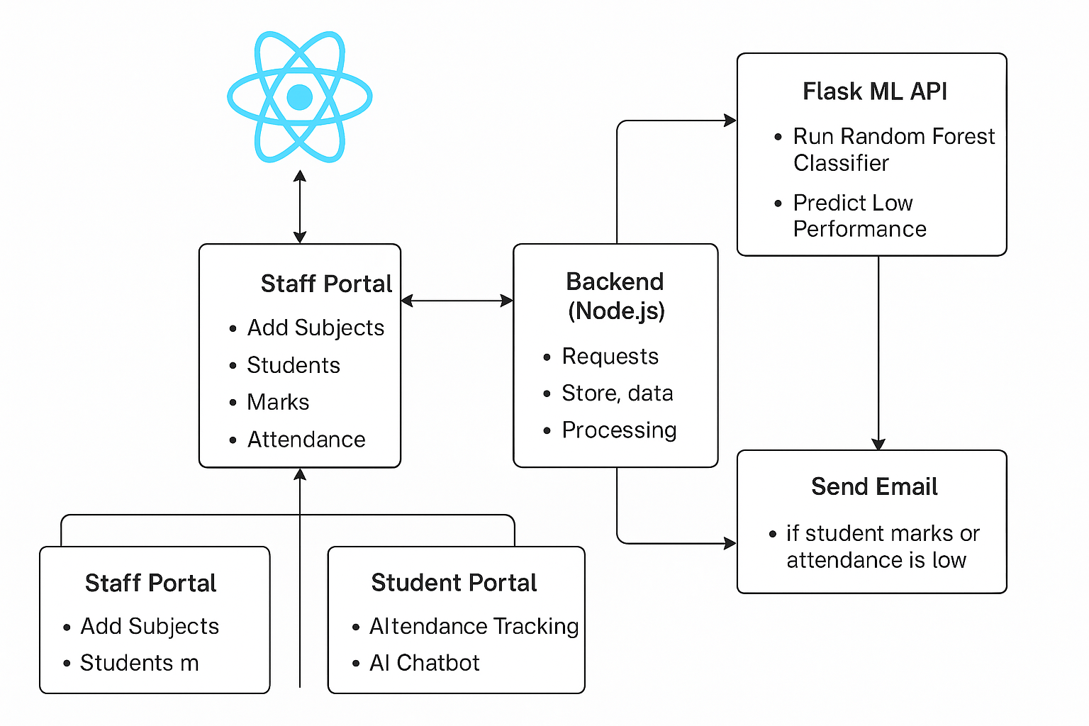

Flow Chart:

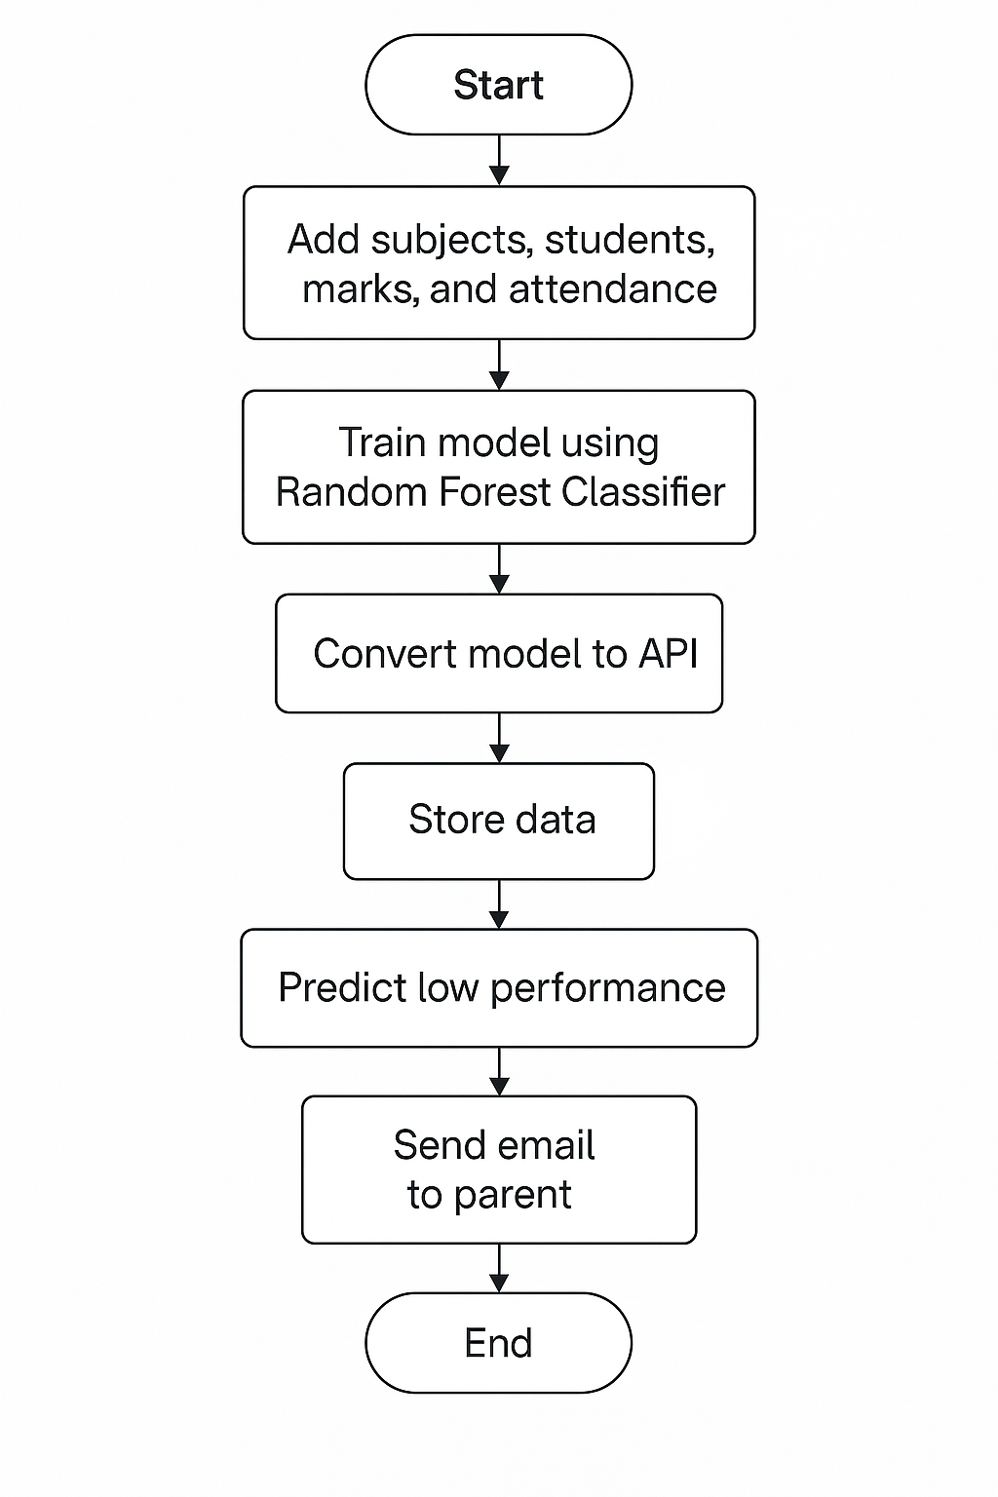
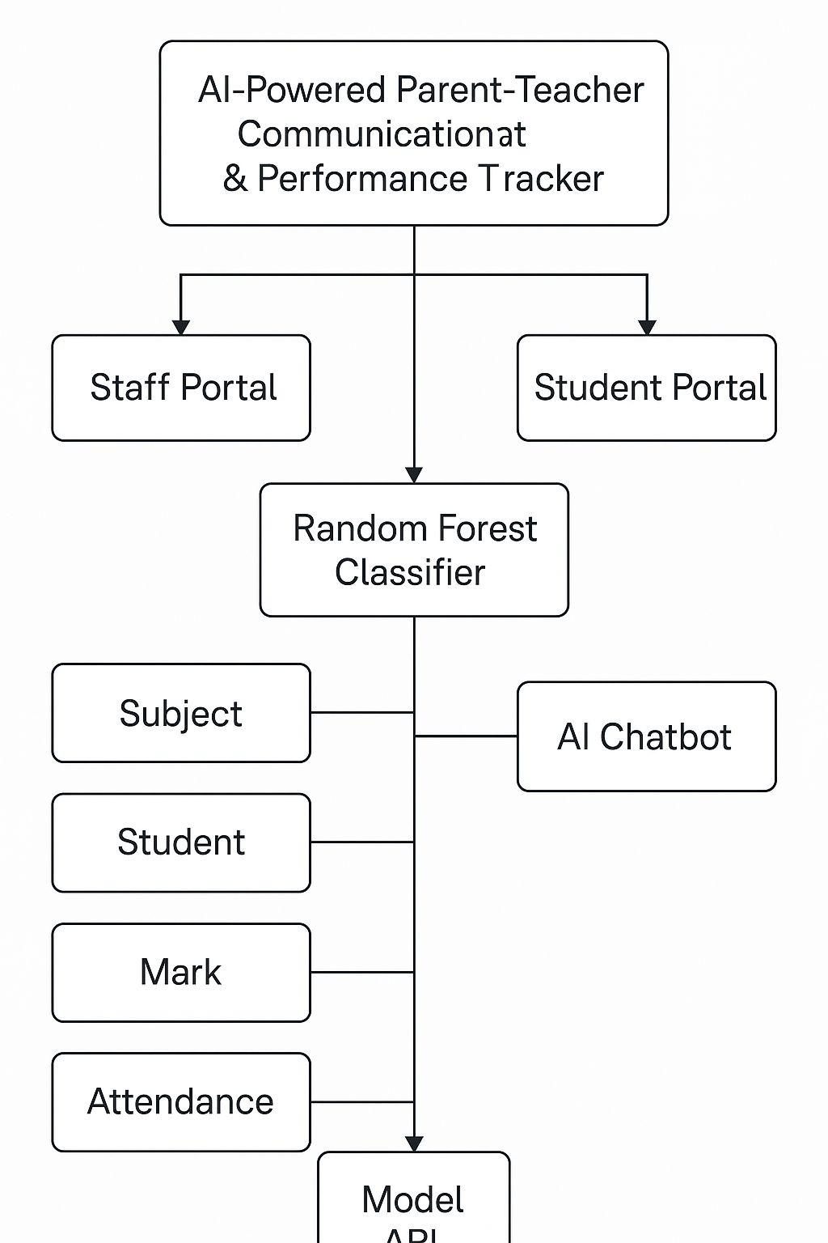

System Design:
